Title: | Windows Lifter  Windows Lifter Design V1.0

History
Issue status  (Index) | Maturity/Date  (draft/invalid/valid)  (dd-mmm-yyyy) | Author  Department | Check/Release  Department | Description
1.0 | Draft  29-Jun-15 | Armando Villa | - | Windows lifter design documentation

Table of Contents
1 Purpose 3
2 Definitions and abbreviations 3
3 Realization constraints and targets 3
4 SW Conceptual design 3
5 SW Component internal breakdown 4
5.1 Functional Decomposition 4
5.2 Function <Type> <function name> (type par 1, .., type par n) 5
5.3 Function <Type> <function name> (type par 1, .., type par n) 5

Purpose
Design and implement a Windows Lifter system using the TRK-MPC5606 to simulate a real Window using 10 leds to this and a pair of leds to indicate the sense of the movement .

Definitions and abbreviations
Definitions
Window Lifter  Anti Pinch | It is a system that controls the movement of the car window.  It is a system that stop the movement of the window when it detects an object or a body part while the window is going up.

Abbreviations
GPIO General Propose Inputs and Outputs
PIT Periodic Interrupt Timer
References
N° | Document name | Reference
1 | Window lifter requirements | Window lifter requirements.docx

Realization constraints and targets

The main propose of this application is simulate and represent a Window Lifter system using Freescale MPC5606B development board using a led array and the embedded buttons to its operation.

SW Conceptual design
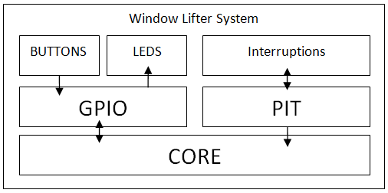

SW Component internal breakdown
To the realization of this application, I decided to make a states machine that on the whole with another header files, performs the operations to simulate a real window behavior.
Mapping to the file structure:
- GPIO This file configure the peripheral pins to the general propose.
- BUTTON This file is designed to count the milliseconds according to the time of the pressed button and later evaluate it.
-STATE MACHINE This is the main function; it is the responsible to evaluate the behavior of the button and realize the appropriate sentences to complete the function.

Functional Decomposition
Overview of functions and their dependencies shown by a Static Function Tree
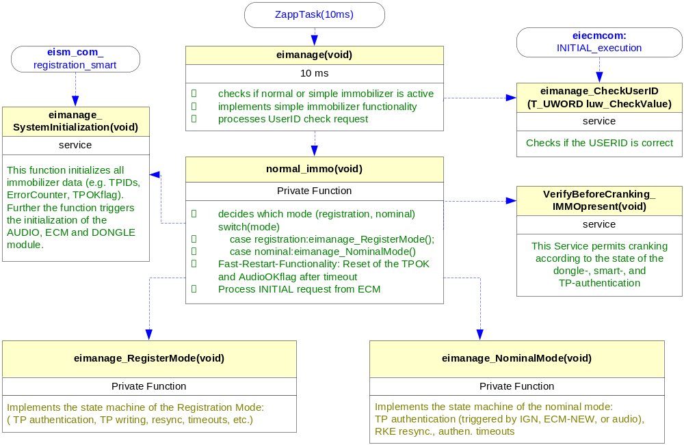
Function Description and Dynamic Behavior
Provide detailed static and dynamic description of all functions of the SW Component.
Functions which are defined in other SW Components shall only be referenced in the external interface description!
The signature description shall be done inside the function header in the source code.
For each function, the following section should be copied

Function <Type> <function name> (type par 1, .., type par n)

Description | Brief description of the function behavior and useful remarks
Parameter 1  <input| output| inout> | Give an explanation if the parameter shall be checked by the user, or if a check is implemented in the function here
Parameter 2..n
Return Value
Precondition | e.g. Function can only be called in a certain state, SW component is initialized  Relation between input parameters where applicable (Input for Module Test)
Post condition | e.g. specific State change e.g. car is locked, EEPROM Values written,  Relation between output parameters where applicable
Error Conditions

Dynamic Behavior
State Chart¹, Flow Chart¹
¹ Preferred
In this document, the dynamic behavior shall be designed on an abstract level showing the principle workflow of a function. Do not show the detailed implementation to ensure that the design description can be maintained with a reasonable effort. The target is not to show the complete detailed implementation 1:1.
The detailed design shall reflect in detail what a function is doing from a black box view. The internal details are useful on an abstract, but not very detailed level.
If the function is not complex a short textual description might be sufficient and a graphical description is not needed.
Symbol and function names shall be self explaining.
The link to the implementation may be provided by using the same names as in the design or by a comment showing the full name followed by the declaration showing the implementation.

Function <Type> <function name> (type par 1, .., type par n)
Description | Brief description of the function behavior and useful remarks
Parameter 1
<input| output| inout>
Parameter 2..n
Return Value
Precondition | e.g. Function can only be called in a certain state, SW component is initialized  Relation between input parameters where applicable (Input for Module Test)
Post condition | e.g. specific State change e.g. car is locked, EEPROM Values written,  Relation between output parameters where applicable
Error Conditions

Dynamic Behavior
State Chart¹, Flow Chart¹, Nassi Shneiderman
¹ Preferred
In this document, the dynamic behavior shall be designed on an abstract level showing the principle workflow of a function. Do not show the detailed implementation to ensure that the design description can be maintained with a reasonable effort. The target is not to show the complete detailed implementation 1:1.
The detailed design shall reflect in detail what a function is doing from a black box view. The internal details are useful on an abstract, but not on a very detailed level.
Symbol and function names shall be self explanatory.
The link to the implementation may be provided by using the same name as in the design or by a comment showing the full name followed by the declaration showing the implementation.

